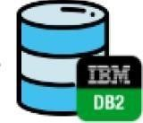

TEAM ID: PNT2022TMID31927

Online

Database

server

Stocks

Refill

Initial/Current

Inventory



Initial data entry

about the stocks in

the

inventory

Login

Into

the

Application

User

)

(

Customer/Retailer



If stock is not

Available/less



If

stock

is

available

Alert send

Customer receives the product